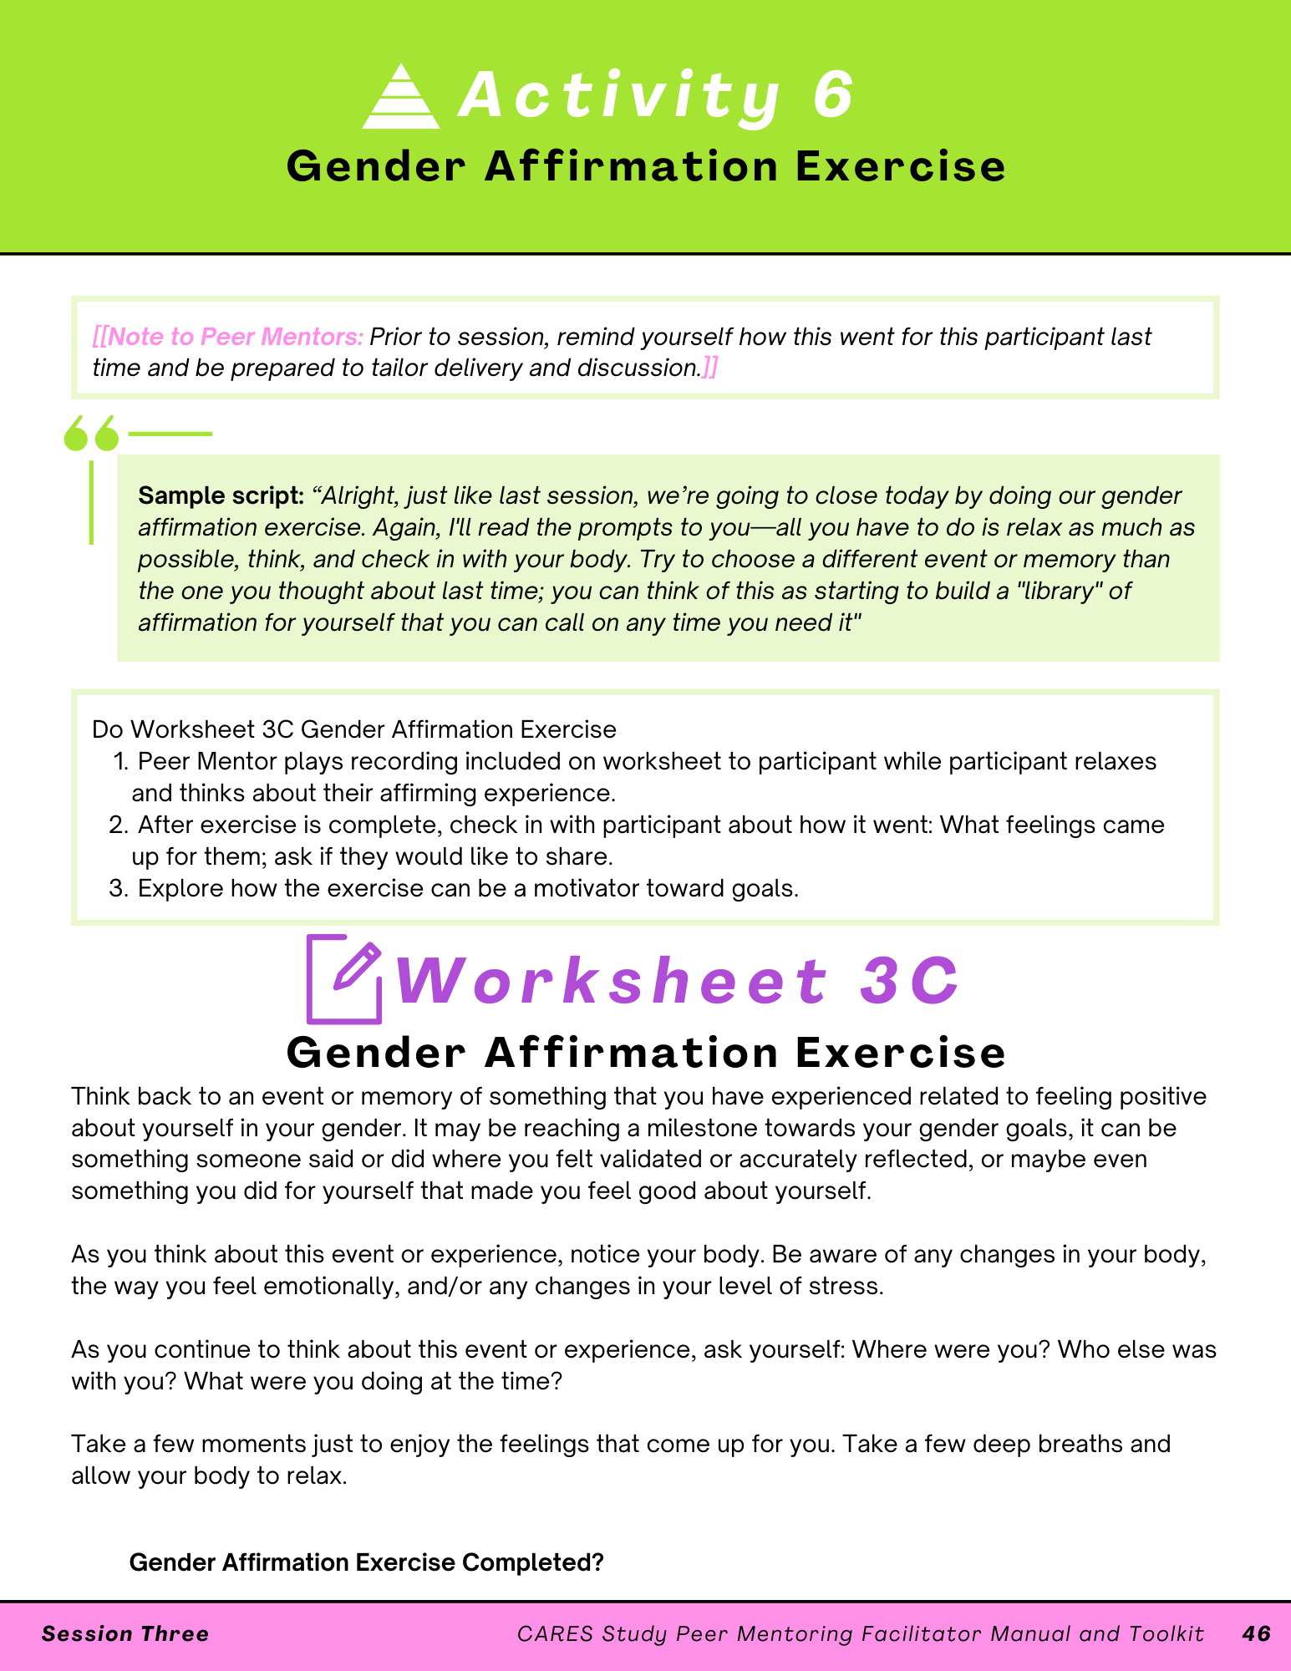

1. Ask the participant if they are able to play a YouTube video. If they tell you yes, send them the video at this link and ask them to follow along with it: <https://youtu.be/7v0tYzYO9Ws>. If they are unable to play a YouTube video right now, try to play it on speakerphone from your phone, as a last resort simply read the words in the Gender Affirmation Exercise.
2. After exercise is complete, check in with participant about how it went: What feelings came up for them, ask if they would like to share.
3. Explore how the exercise can be a motivator toward goals.